AUTOMATIC IRRIGATION SYSTEM

*A Project report submitted in partial fulfilment*

*of the requirements for the degree of B. Tech in CSE(IOT)*

*By*

## *ANUJ PRAKASH(2001321550011)*

## *GAURAV SINGH(2001321550015)*

## *KUNDAN KUMAR(2001321550020)*

## *HIMANSHU PRAYER(2001321550017)*

*Under the supervision of*

***DR. INDRDEEP******VERMA***

**PROFESSOR & HOD**

## DEPARTMENT OF CS(IOT)



***CERTIFICATE***

# To whom it may concern

This is to certify that the project work entitled **AUTOMATIC IRRIGATION SYSTEM** is the bona fide work carried out by **KUNDAN KUMAR , HIMANSHU PRAYER, ANUJ PRAKASH, GAURAV SINGH**  student of B.Tech in the Dept. of (CS-IOT), GREATER NOIDA INSTITUTE OF TECHNOLOGY T (GNIOT), affiliated to (AKTU), LUCKNOW, UP during the academic year 2022-23, in partial fulfillment of the requirements for the degree of Bachelor of Technology in CS(IOT) and that this project has not submitted previously for the award of any other degree, diploma and fellowship.

**Signature of the Guide Signature of the HOD**

**Name:** DR INDRADEEP VERMA **Name: DR.INDRADEEP VERMA**

**Designation:** PROFESSOR & HOD **Designation:** PROFESSOR & HOD

1

## ACKNOWLEDGEMENT

It is my great fortune that I have got opportunity to carry out this project work under the supervision of **DR. INDRADEEP VERMA**, in the Department of CS(IOT), GREATER NOIDA INSTITUTE OF TECHNOLOGY (GNIOT), affiliated to (AKTU). I express my sincere thanks and deepest sense of gratitude to my guide for his constant support, unparalleled guidance and limitless encouragement.

I wish to convey my gratitude to **Prof. (Dr.) Indradeep Verma**, **HOD**, Department of CSE(IOT) for providing all kinds of infrastructural facility towards the research work.

I would also like to convey my gratitude to all the faculty members and staffs of the Department of CS(IOT), GNIOT for their whole hearted cooperation to make this work turn into reality.

### Name and Signature of the Students

**Place:** **Date:**

# : TABLE OF CONTENTS :

Page no

List of Tables iii

List of Figures iii

Abstract iv

CHAPTER 1: ENABLING TECHNOLOGIES

* 1. Introduction 1
  2. Motivation 1
  3. Literature Survey 2
  4. Irrigation Control System Function 4
  5. Advantages of Automatic Irrigation Control 5
  6. Flow Chart 6

CHAPTER 2: PROPOSED SYSTEM HARDWARE AND ARCITECTURE

* 1. Component List 7
  2. Arduino 8
  3. DHT11 Temperature and Humidity Sensor 10
  4. Tiny RTC 12
  5. Light Emitting Diode 13
  6. Resistors 13
  7. Relay Module 14
  8. Diode 15
  9. MOSFET 15
  10. DC Motor 16

CHAPTER3: PROPOSED ALGORITHM

1.1 Software Designing 17

CHAPTER 4: SYSTEM IMPLEMENTATION

* 1. Schematic Diagram 25
  2. Result 26

CHAPTER5: CONCLUSION AND FUTURE WORK

* 1. Conclusion 29
  2. Future Works 29
  3. Reference 30

### List of Tables Page No

Table 1: Component list of proposed system **7**

### List of Figures

Fig 1: Arduino uno architecture **8**

Fig 2: Temperature & Humidity Sensor **10**

Fig 3: Real Time Clock (RTC) 12

Fig 4: LED **13**

Fig 5: Resistor **13**

Fig 6: Relay Module **14**

Fig 7: Connection Diagram of Relay with Arduino 14

Fig 8: Diode 15

Fig 9: MOSFET **15**

Fig 10: DC Motor 16

Fig 11: Circuit Schematic Diagram of the System 25

Fig 12: Pictorial Circuit Diagram of the System 25

Fig 13: Print setting of Valve **26**

Fig 14: Output Result When Humidity less than 80% 27

Fig 15: Output When Humidity more than 80% 27

Fig 16: Hardware Model of the System **28**

Fig 17: Block diagram of the System 29

# *ABSTRACT*

With the advancement of automation technology, life is getting simpler and easier in all aspects. In today’s world Automatic systems are being preferred over manual system. Automatic system is a growing system of everyday object from industrial machine to consumer goods that can complete tasks while you are busy with other activities.

India's population is reached beyond 1.2 billion and the population rate is increasing day by day then after 25-30 years there will be serious problem of food, so the development of agriculture is necessary. Today, the farmers are suffering from the lack of rains and scarcity of water. The main objective of this paper is to provide an automatic irrigation system thereby saving time, money & power of the farmer. The traditional farmland irrigation techniques require manual intervention. With the automated technology of irrigation the human intervention can be minimized.

Whenever there is a change in temperature and humidity of the surroundings these sensors senses the change in temperature and humidity and gives an interrupt signal to the micro-controller.

# CHAPTER 1: ENABLING TECHNOLOGIES

## INTRODUCTION

India is the country of village and agriculture plays an important role for development of country. In our country, agriculture depends on the monsoons which has insufficient source of water. So the irrigation is used in agricultural field In Irrigation system, depending upon the soil type, water is provided to plant. In agriculture, two things are very important, first to get information of about the fertility of soil and second to measure humidity content in air. Nowadays, for irrigation, different techniques are available which are used to reduce the dependency of rain. And mostly this technique is driven by electrical power and on/off scheduling. In this technique, an temperature and humidity sensors are placed near the plant and near the module and gateway unit handles the sensor information and transmit data to the controller which in turns the control the flow of water through the pump. Embedded systemsl Il are finding increasing application only in Domestic applications but also in areas of' industrial automation. automobiles, power electronics. defense and space equipment's, Microcontrollers from the basic building blocks for many embedded systems.

The using ATS9S51 micro controller, which is used to regulMe the power flowing in the a,C. load using a sending signals  controller AT*9S$l as interrupts, The device is manufactured using Atrnel•s high •density non-volatile memory technology and is compatible with the industry standards MCS-5i instruction set. By vombining a versatile S-bit CPU with flash on a monolithic chip. the ATS9SSl is a powerfill micro controller which provides a highly and effective solution many embedded control applications.

Other 3•channcls are used for ON / OFF type control or for switching devices.

 revolution of home networking is an ernerging technology in this digital era. Like many other J.C drives gets to be automated with the embedded controllers for most of the devices for safety at residential areas Or in industries. The project is an attempt to implementation of few consumer electronic products mostly at homes.

## MOTIVATION

For continuously increasing demand and decrease in supply of food necessities, it’s important to rapid improvement in production of food technology. Agriculture is only the source to provide this. This is the important factor in human societies to growing and dynamic demand in food production. Agriculture plays the important role in the economy and development, like India. Due to lack of water and scarcity of land water result the decreasing volume of water on earth, the farmer use irrigation. Irrigation may be defined as the science of artificial application of water to the land or soil that means depending on the soil type

**[BOOK]** [**Review** of selected **literature** on indicators](https://books.google.co.in/books?hl=en&lr&id=6xUuzkrFlzwC&oi=fnd&pg=PP6&dq=literature%2Bsurvey%2Bof%2Bautomatic%2Birrigation%2Bsystem&ots=wPQnIC5N5V&sig=-20Pfl5_DmYlawNaJJwoWDnQaoQ) [of **irrigation** performance](https://books.google.co.in/books?hl=en&lr&id=6xUuzkrFlzwC&oi=fnd&pg=PP6&dq=literature%2Bsurvey%2Bof%2Bautomatic%2Birrigation%2Bsystem&ots=wPQnIC5N5V&sig=-20Pfl5_DmYlawNaJJwoWDnQaoQ)

PS Rao - 1993 - books.google.com

… A list of performance indicators classified with respect to the **system** and authors is given in

Appendix 2. The **review** is limited, not exhaustive, and is confined to a selected set of **literature**

in the … Figure 1. Inputs and outputs: **Irrigation** in the context of nested **systems** …

[Renewable energy source water pumping](https://www.sciencedirect.com/science/article/pii/S1364032113002633) **[systems](https://www.sciencedirect.com/science/article/pii/S1364032113002633)**[—A](https://www.sciencedirect.com/science/article/pii/S1364032113002633) **[literature](https://www.sciencedirect.com/science/article/pii/S1364032113002633)** [**review**](https://www.sciencedirect.com/science/article/pii/S1364032113002633)

C Gopal, M Mohanraj, [P Chandramohan](https://scholar.google.co.in/citations?user=jkWyAZ8AAAAJ&hl=en&oi=sra)… - … and Sustainable Energy …, 2013 - Elsevier

… Volume 25, September 2013, Pages 351-370. Renewable and Sustainable Energy Reviews.

Renewable energy source water pumping **systems**—A **literature review** …

However, there is no

specific **review on** RESWPSs … The remaining part of this **review** contains nine sections …

[Design of remote monitoring and control](http://search.proquest.com/openview/33fc77a78ea81abc6c4a53002c5d32cf/1?pq-origsite=gscholar&cbl=136216) **[system](http://search.proquest.com/openview/33fc77a78ea81abc6c4a53002c5d32cf/1?pq-origsite=gscholar&cbl=136216)** [with](http://search.proquest.com/openview/33fc77a78ea81abc6c4a53002c5d32cf/1?pq-origsite=gscholar&cbl=136216) **[automatic](http://search.proquest.com/openview/33fc77a78ea81abc6c4a53002c5d32cf/1?pq-origsite=gscholar&cbl=136216)** [**irrigation system** using GSM-bluetooth](http://search.proquest.com/openview/33fc77a78ea81abc6c4a53002c5d32cf/1?pq-origsite=gscholar&cbl=136216)

SRN Reddy - International Journal of Computer Applications, 2012 - search.proquest.com

… of a GSM-Bluetooth based remote monitoring and control **system** with **Automatic irrigation system**

has been … The study and **literature survey** based on research papers is proposed in this paper …

1. Healy, M. Newe, T. Lewis Wireless Sensor Node hardware: A **review**, IEEE 15th …

**[Review](https://www.sciencedirect.com/science/article/pii/S0378377404001416)** [of measured crop water productivity values](https://www.sciencedirect.com/science/article/pii/S0378377404001416) [for **irrigated** wheat, rice, cotton and maize](https://www.sciencedirect.com/science/article/pii/S0378377404001416)

[SJ Zwart](https://scholar.google.co.in/citations?user=cr88axsAAAAJ&hl=en&oi=sra), [WGM Bastiaanssen](https://scholar.google.co.in/citations?user=Iu8wR40AAAAJ&hl=en&oi=sra) - Agricultural water management, 2004 - Elsevier

… et al., 1998) has not been regarded as being suitable for the current **review**; evapotranspiration

is … Many examples from **literature** describe the influence of **irrigation** water management on CWP

(eg Oktem … It was found that without **irrigation** CWP in rainfed **systems** is low, but that …

## IRRIGATION CONTROL SYSTEM FUNCTION

* + **User Interface:** User interface allow the user to inter act with the system by sending information to the controller by presenting information to user about the system. Its generally a computer or a smartphone
  + **Controlled Devices:** Controlled devices include a wide range of equipment that this arduino and sensor is capable of. Here in our project it is a motor.
  + **Programming Computer:** Some system controllers allow the user to program the system with the systems own user interface. Other system require PC to program. Here we are accessing arduino IDE with the help of a PC.
  + **Controllers:** Relay controllers provide the intelligent control functions in automatic irrigation control.
  + **Sensing Devices:** Sensing devices can report values, such as temperature and humidity etc or states.
  + **I/O Interface Devices:** These devices provide the logical communication link between the controllers and the controlled device systems.

## ADVANTAGES OF AUTOMATIC IRRIGAION CONTROL

### Prevents Disease and Weeds

Specialized drip irrigation systems direct water specifically to each plant's root ball, rather than sprinkling the entire garden like a typical rainstorm. As a result, surrounding weed seeds cannot germinate, so you'll have less weeding to do. Water at the roots also prevents leaf diseases caused by standing droplets on the foliage. Because the water does not strike the leaves or flowers, blight diseases have no chance of proliferating.

### Conserves Water and Time

Hand watering with a hose or watering can takes substantial time and early morning and evening watering rituals take away from family and work. Both drip and sprinkler irrigation systems have timers that can be preset for daily or weekly watering so you do not need to monitor the watering because the timer shuts the water off when it has finished. Your water bill should be lower if the irrigation system is effective.

### Preserves Soil Structure and Nutrients

Watering with a wide open garden hose may allow too much water to seep into the soil. As a result, nutrients leach out with the water runoff, leaving the plants with fewer nutrients available. The soil may also become compacted when you water with a hose. Plants may show signs of withering or root disease with suffocating, compacted soil. Using either drip or sprinkler irrigation produces smaller droplets, helping to preserve nutrients and reducing soil compaction.

### Gardening Flexibility

If you have a busy schedule, you'll appreciate being able to work in the garden at the same time as the plants are being watered. While one garden section is being watered, you can plant and prune in another area.



STOP

Motor keep Running

* 1. **FLOW CHART OF THE SYSTEM**



Start

Check

Supply

Start

RTC

Get Temperature and humidity



Humidity

>80?

RTC

Reached Offtime??

NO

Yes

Start Motor

NO

Open weather API

Yes

Stop Pump

Set On And Off Time of Relay

# CHAPTER 2: PROPOSED SYSTEM HARDWARE AND ARCHITECTURE

## COMPONENT LIST

|  |  |  |
| --- | --- | --- |
| SL NO | NAME OF COMPONENTS | QUANTITY |
| 1 | Arduino UNO | 1 |
| 2 | Real Time Clock | 1 |
| 3 | DHT11 Temperature and Humidity Sensor | 1 |
| 4 | Electric DC Motor | 1 |
| 5 | Relay Module | 1 |
| 6 | 1 k Resistor | 1 |
| 7 | Power Supply cord for Arduino | 1 |
| 8 | MOSFET | 1 |
| 9 | Female Headers | 10 |
| 10 | Male Headers | 10 |
| 11 | Diode | 1 |
| 12 | Jumper wire | 20 |

Table 1: Component list of proposed system

## ARDUINO

Arduino is an open source physical computing platform based on simple input/output board and a development environment that implements the Processing language (www.processing.org). Arduino can be used to develop standalone interactive objects or can be connected to software on your computer. The boards can be assembled by hand or purchased preassembled; the open source IDE(Integrated Development Environment) can be downloaded for free from [www.arduino.cc](http://www.arduino.cc/)

## Introduction to Arduino Boards:

Arduino is an architecture that combines Atmel microcontroller family with standard hardware into a board with inbuilt boot loader for plug and play embedded programming. Arduino Software comes with an IDE that helps writing, debugging and burning program into Arduino. The IDE also comes with a Serial Communication window through which can easily get the serial data from the board.

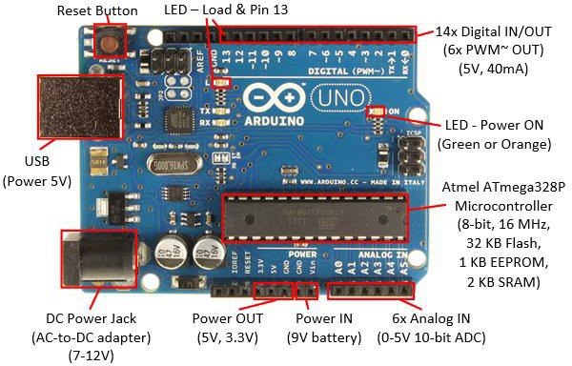

Fig 1: ARDUINO UNO ARCHITECTURE

## Pin Description of Arduino Uno:

The Uno is a microcontroller board based on the ATmega328P. It has 14 digital input/output pins (of which 6 can be used as PWM outputs), 6 analog inputs, a 16 MHz quartz crystal, a USB connection, a power jack, an ICSP header and a reset button. Each of the 14 digital pins can be used as an input or output, using pin Mode (), digital Write (), and digital Read () functions. They operate at 5 volts. Each pin can provide or receive 20 mA as recommended operating condition and has an internal pull-up resistor (disconnected by default) of 20-50k ohm. A maximum of 40mA is the value that must not be exceeded on any I/O pin to avoid permanent damage to the microcontroller.

In addition, some pins have specialized functions:

* + - * Serial: 0(RX) and 1(TX). Used to receive (RX) and Transmit (TX) TTL serial data.
      * External Interrupts: 2 and 3. These pins can be configured to trigger an interrupt on a low value, a rising or falling edge, or a change in value.
      * PWM: 3, 5, 6, 9, 10, and 11. Provide 8-bit PWM output with the analog Write() function.
      * SPI: 10(SS), 11(MOSI), 12(MISO), 13(SCK). These pins support SPI communication using the SPI library.
      * LED: 13. There is a built-in LED driven by digital pin 13.
      * TWI: A4 or SDA pin and A5 or SCL pin. Support TWI communication using the wire library.

The Uno has 6 analog inputs, labeled A0 through A5, each of which provide 10 bits of resolution. By default they measure from ground to 5 volts, through is it possible to change the upper end of their range using the AREF pin and the analog Reference () function.

There are a couple of other pins on the board.

* + - * AREF Reference voltage for the analog inputs. Used with analog Reference.
      * Reset. Bring this line LOW to reset the microcontroller. Typically used to add a reset button to shields which block the one on the board.

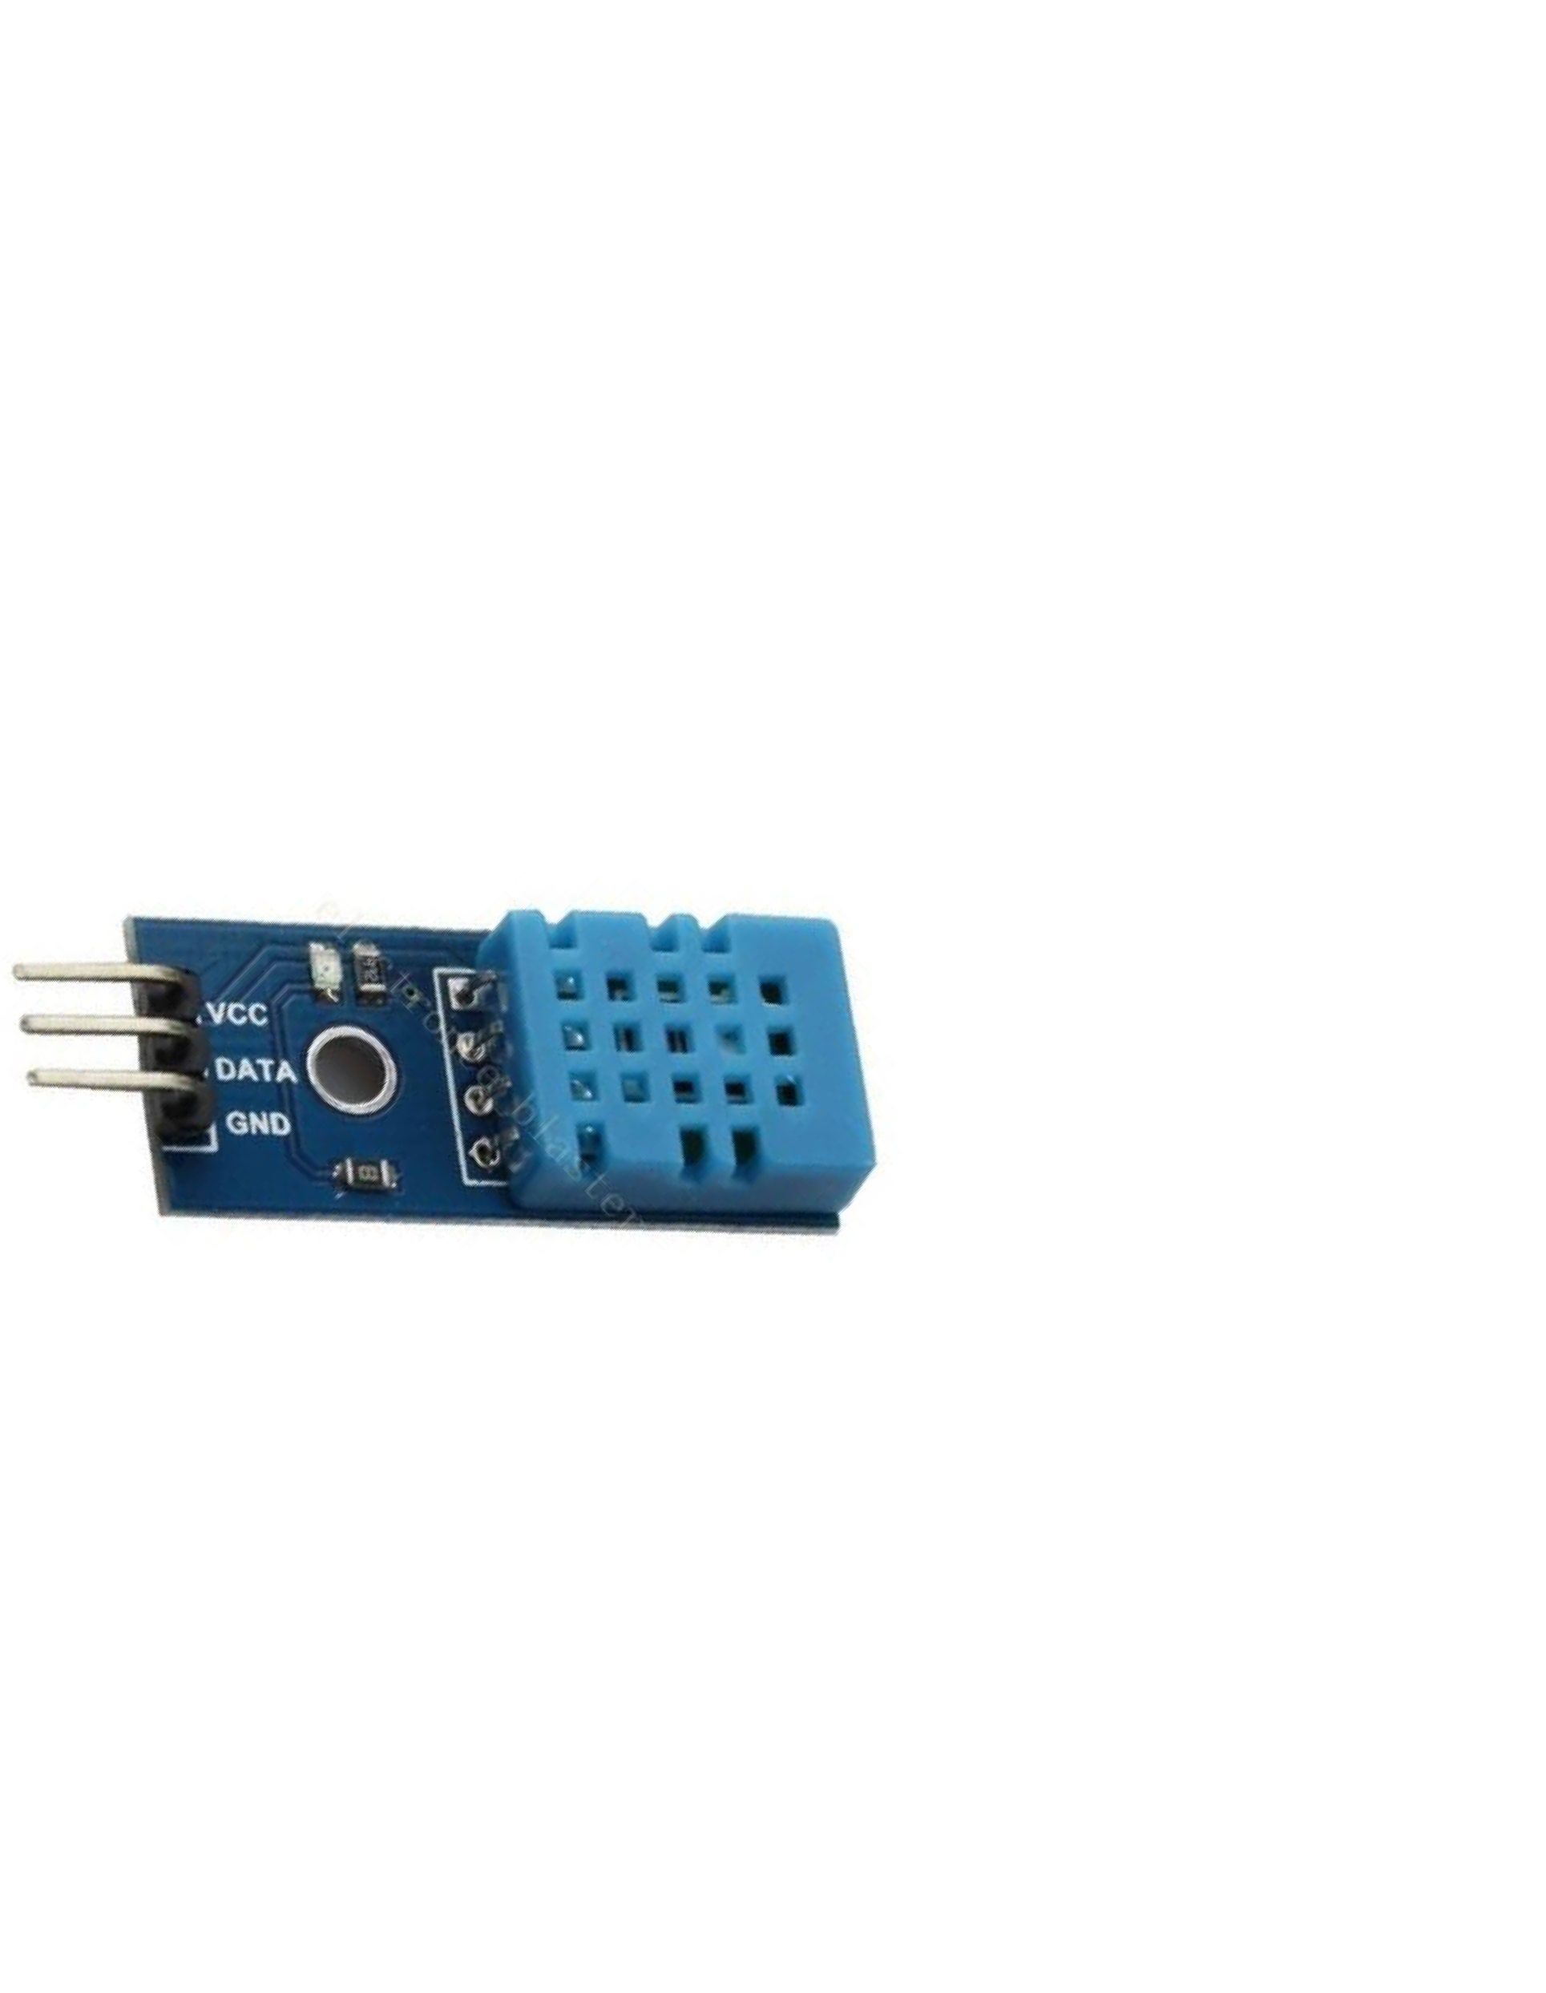

## DHT11 TEMPERATURE AND HUMIDITY SENSOR

DHT11 digital temperature and humidity sensor is a composite Sensor contains a calibrated digital signal output of the temperature and humidity. Application of a dedicated digital modules collection technology and the temperature and humidity sensing technology, to ensure that the product has high reliability and excellent long-term stability. The sensor includes a resistive sense of wet components and an NTC temperature measurement devices, and connected with a high-performance 8-bit microcontroller.

They consist of a humidity sensing component, a NTC temperature sensor (or thermistor) and an IC on the back side of the sensor. For measuring humidity they use the humidity sensing component which has two electrodes with moisture holding substrate between them. So as the humidity changes, the conductivity of the substrate changes or the resistance between these electrodes changes. This change in resistance is measured and processed by the IC which makes it ready to be read by a microcontroller.

On the other hand, for measuring temperature these sensors use a NTC temperature sensor or a thermistor. A thermistor is actually a variable resistor that changes its resistance with change of the temperature. These sensors are made by sintering of semi conductive materials such as ceramics or polymers in order to provide larger changes in the resistance with just small changes in temperature. The term “NTC” means “Negative Temperature Coefficient”, which means that the resistance decreases with increase of the temperature.

Fig 2: Temperature & Humidity Sensor

## Features of DHT11

* It measures both air temperature and moisture.
* Relative humidity expressed as a percentage.
* HS1100 is used for sensing humidity.
* The output in terms of frequency range 5khz to 10khz.
  1. **REAL TIME CLOCK (RTC)**

Real time clocks (RTC), as the name recommends are clock modules. The DS1307 real time clock (RTC) IC is an 8 pin device using an I2C interface. The DS1307 is a low-power clock/calendar with 56 bytes of battery backup SRAM. The clock/calendar provides seconds, minutes, hours, day, date, month and year qualified data. The end date of each month is automatically adjusted, especially for months with less than 31 days.

They are available as integrated circuits (ICs) and supervise timing like a clock and also operate date like a calendar. The main advantage of RTC is that they have an arrangement of battery backup which keeps the clock/calendar running even if there is power failure. An exceptionally little current is required for keeping the RTC animated. We can find these RTCs in many applications like embedded systems and computer mother boards, etc.

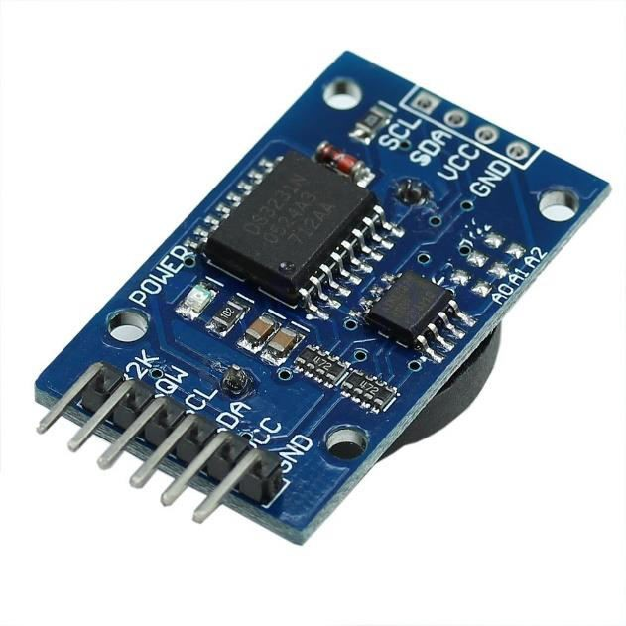

Fig 3: Real Time Clock (RTC)

### Working of DS1307:

In the simple circuit the two inputs X1 and X2 are connected to a 32.768 kHz crystal oscillator as the source for the chip. VBAT is connected to positive culture of a 3V battery chip. Vcc power to the I2C interface is 5V and can be given using microcontrollers. If the power supply Vcc is not granted read and writes are inhibited.

* 1. **LIGHT EMITTING DIODE (LED)**

A light-emitting diode (LED) is a two-lead semiconductor light source. It is a p- n junction diode that emits light when activated. When a suitable voltage is applied to the leads, electrons are able to recombine with electron holes within the device, releasing energy in the form of photons. This effect is called electroluminescence, and the colour of light (corresponding to the energy of the photon) is determined by the energy band gap of the semiconductor. LEDs are typically small (less than 1 mm2) and integrated optical components may be used to shape the radiation pattern.

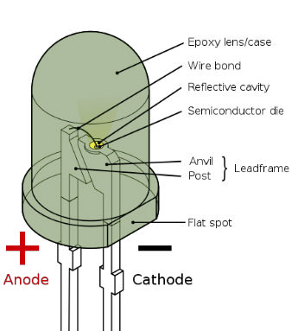

Fig 4: LED

## RESISTORS

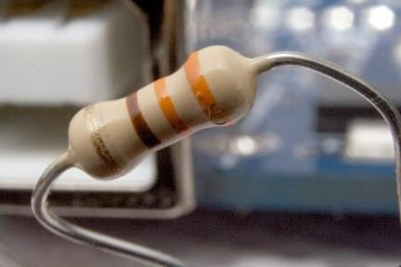A resistor is a passive two-terminal electrical component that implements electrical resistance as a circuit element. In electronic circuits, resistors are used to reduce current flow, adjust signal levels, to divide voltages, bias active elements, and terminate transmission lines, among other uses. High-power resistors that can dissipate many watts of electrical power as heat may be used as part of motor controls, in power distribution systems, or as test loads for generators. Fixed resistors have resistances that only change slightly with temperature, time or operating voltage. Variable resistors can be used to adjust circuit elements (such as a volume control or a lamp dimmer), or as sensing devices for heat, light, humidity, force, or chemical activity.

Fig 5: Resistor

## RELAY MODULE

Relay is an electromagnetic device which is used to isolate two circuits electrically and connect them magnetically. They are very useful devices and allow one circuit to switch another one while they are completely separate. They are often used to interface an electronic circuit (working at a low voltage) to an electrical circuit which works at very high voltage. For example, a relay can make a 5V DC battery circuit to switch a 230V AC mains circuit. Thus a small sensor circuit can drive, say, a fan or an electric bulb.

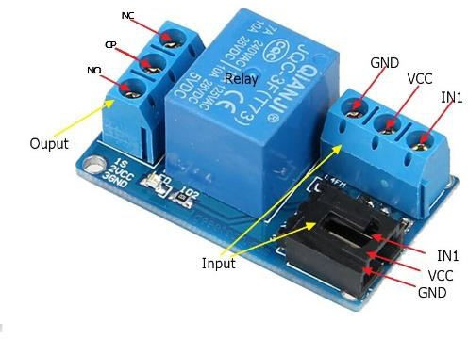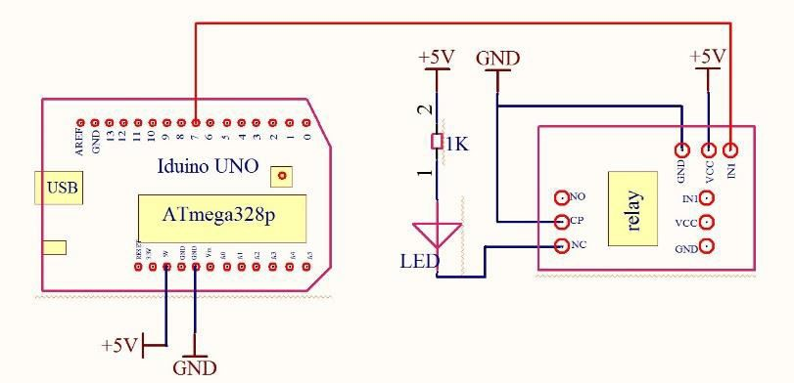

Fig 6: Relay Module Fig 7: Connection Diagram of Relay

with Arduino

A relay switch can be divided into two parts: input and output. The output section has a coil which generates magnetic field when a small voltage from an electronic circuit is applied to it. This voltage is called the operating voltage. Commonly used relays are available in different configuration of operating voltages like 6V, 9V, 12V, 24V etc. the output section consists of contactors which connect or disconnect mechanically. In a basic relay there are three contactors: normally open (NO), normally closed (NC) and common (COM). At no point state, the COM is connected to NC. When the operating voltage is applied the relay coil gets energized and the COM changes contact to NO.

* 1. **DIODE (IN4148)**

In electronics, a diode is a two-terminal electronic component that conducts primarily in one direction (asymmetric conductance), it has low (ideally zero) resistance to the flow of current in one direction, and high (ideally infinite) resistance in the other. A semiconductor diode is a crystalline piece of semiconductor material with a p-n junction connected to two electrical terminals.

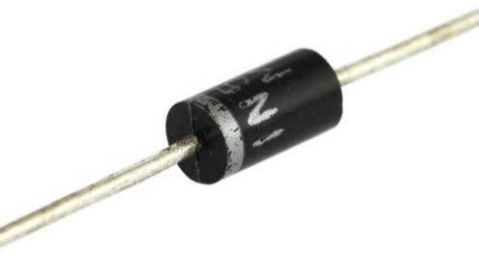

## MOSFET

Fig 8: Diode

The 2N7000 MOSFET is an [N-channel](https://en.wikipedia.org/wiki/N-type_semiconductor), [enhancement-mode](https://en.wikipedia.org/wiki/Field-effect_transistor#FET_operation) [MOSFETs](https://en.wikipedia.org/wiki/MOSFET) used for low-power switching applications, with different lead arrangements and current ratings.

The 2N7000 is a widely available and popular part, often recommended as useful and common components to have around for hobbyist use.

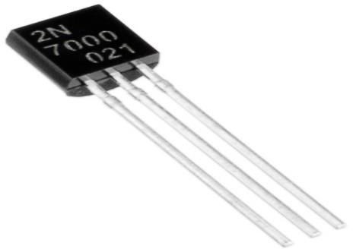

Fig 9: MOSFET

The 2N7000 is 60 [V](https://en.wikipedia.org/wiki/Volt) devices and it can switch 200 [mA](https://en.wikipedia.org/wiki/Ampere). The 2N7002 is another different part with different resistance, current rating and package. The 2N7002 is also known as "small outline transistor" SOT-23 [surface-mount](https://en.wikipedia.org/wiki/Surface-mount_technology), which is the most commonly used three-lead surface-mount package.

## DC MOTOR

A DC motor is any of a class of rotary electrical machines that converts direct current electrical energy into mechanical energy. The most common types rely on the forces produced by magnetic fields. Nearly all types of DC motors have some internal mechanism, either electromechanical or electronic, to periodically change the direction of current flow in part of the motor.

DC motors were the first type widely used, since they could be powered from existing direct-current lighting power distribution systems. A DC motor's speed can be controlled over a wide range, using either a variable supply voltage or by changing the strength of current in its field windings. Small DC motors are used in tools, toys, and appliances.

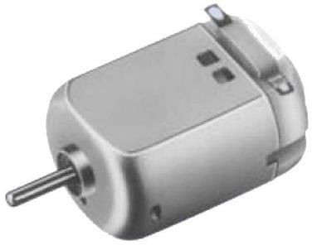

Fig 10: DC Motor

**Block diagram**

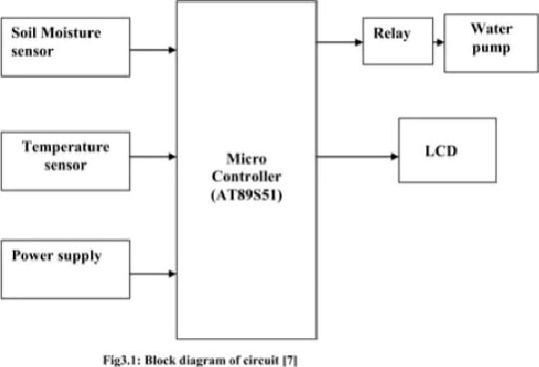

# CHAPTER 3: PROPOSED ALGORITHM

## 3.1 SOFTWARE DESIGNING

#include <Wire.h> // Wire library, used by RTC library #include "RTClib.h" // RTC library

#include "DHT.h" // DHT temperature/humidity sensor library

// Analog pin usage

const int RTC_5V_PIN = A3; const int RTC_GND_PIN = A2;

// Digital pin usage

const int DHT_PIN = 2; // temperature/humidity sensor const int NUMBEROFTIMES = 2;

int onOffTimes[NUMBEROFTIMES]; const int ONTIME = 0;

const int OFFTIME = 1; #define DHTTYPE DHT11

DHT dht(DHT_PIN, DHTTYPE); // Create a DHT object RTC_DS1307 rtc; // Create an RTC object

DateTime dateTimeNow; // to store results from the RTC

// to store humidity result from the DHT11 sensor

float humidityNow; void setup(){

// Power and ground to RTC pinMode(RTC_5V_PIN, OUTPUT); pinMode(RTC_GND_PIN, OUTPUT);

digitalWrite(RTC_5V_PIN, HIGH); digitalWrite(RTC_GND_PIN, LOW);

// Initialize the wire library #ifdef AVR

Wire.begin(); #else

// Shield I2C pins connect to alt I2C bus on Arduino Due Wire1.begin();

#endif

rtc.begin(); // Initialize the RTC object dht.begin(); // Initialize the DHT object Serial.begin(9600); // Initialize the Serial object

// Set the water valve pin numbers into the array

// and set those pins all to outputs pinMode(8, OUTPUT);

};

void loop() {

// Remind user briefly of possible commands

Serial.print("Type 'P' to print settings or "); getTimeTempHumidity();

// Check for request from the user checkUserInteraction();

// Check to see whether it's time to turn any valve ON or OFF checkTimeControlValves();

// No need to do this too frequently delay(5000)

}

void getTimeTempHumidity() {

// Get and print the current time dateTimeNow = rtc.now();

if (! rtc.isrunning()) { Serial.println("RTC is NOT running!");

rtc.adjust(DateTime( DATE , TIME )); return;

}

Serial.print(dateTimeNow.hour(), DEC); Serial.print(':'); Serial.print(dateTimeNow.minute(), DEC); Serial.print(':'); Serial.print(dateTimeNow.second(), DEC); humidityNow = dht.readHumidity();

// Read temperature as Celsius float t = dht.readTemperature();

// Read temperature as Fahrenheit float f = dht.readTemperature(true).

if (isnan(humidityNow) || isnan(t) || isnan(f)) { Serial.println("Failed to read from DHT sensor!"); return; // if the DHT is not running don't continue;

}

Serial.print(" Humidity "); Serial.print(humidityNow); Serial.print("% "); Serial.print("Temp "); Serial.print(t); Serial.print("C "); Serial.print(f); Serial.print("F"); Serial.println();

} // end of getTimeTempHumidity: void checkUserInteraction() {

// Check for user interaction while (Serial.available() > 0) { char temp = Serial.read();

if ( temp == 'P') { printSettings(); Serial.flush(); break;

}

// If first character is 'S' then the rest will be a setting else if ( temp == 'S') {

expectValveSetting();

}

else

{

printMenu(); Serial.flush(); break;

void expectValveSetting() { char onOff = Serial.read();

int desiredHour = Serial.parseInt(); if (Serial.read() != ':') {

Serial.println("no : found"); // Sanity check Serial.flush();

return;

}

int desiredMinutes = Serial.parseInt(); int desiredMinutesSinceMidnight

= (desiredHour*60 + desiredMinutes); if ( onOff == 'N') { // it's an ON time onOffTimes[ONTIME]

= desiredMinutesSinceMidnight;

}

else if ( onOff == 'F') { // it's an OFF time onOffTimes[OFFTIME]

= desiredMinutesSinceMidnight;

}

else { // user didn't use N or F

Serial.print("You must use upper case N or F "); Serial.println("to indicate ON time or OFF time"); Serial.flush();

return;

}

printSettings();

}

void checkTimeControlValves() { int nowMinutesSinceMidnight =

(dateTimeNow.hour() * 60) + dateTimeNow.minute();

// Now check the array for each valve Serial.print("Valve ");

Serial.print(" is now ");

if ( ( nowMinutesSinceMidnight >= onOffTimes[ONTIME]) &&

( nowMinutesSinceMidnight < onOffTimes[OFFTIME]) ) {

// Before we turn a valve on make sure it's not raining if ( humidityNow > 80 ) {

// It's raining; turn the valve OFF Serial.print(" OFF "); digitalWrite(8, LOW);

}

else {

// No rain and it's time to turn the valve ON Serial.print(" ON ");

digitalWrite(8, HIGH);

} // end of checking for rain

}

else {

Serial.print(" OFF ");

digitalWrite(8, LOW);

}

Serial.println();

// end of looping over each valve Serial.println();

}

void printMenu() { Serial.println(

"Please enter P to print the current settings");

}

void printSettings(){ Serial.println(); { Serial.print("Valve "); Serial.print(" will turn ON at ");

Serial.print((onOffTimes[ONTIME])/60); Serial.print(":"); Serial.print((onOffTimes[ONTIME])%(60)); Serial.print(" and will turn OFF at "); Serial.print((onOffTimes[OFFTIME])/60); // hours Serial.print(":"); Serial.print((onOffTimes[OFFTIME])%(60)); // minutes Serial.println();

}

# CHAPTER 4: Irrigation System implementation

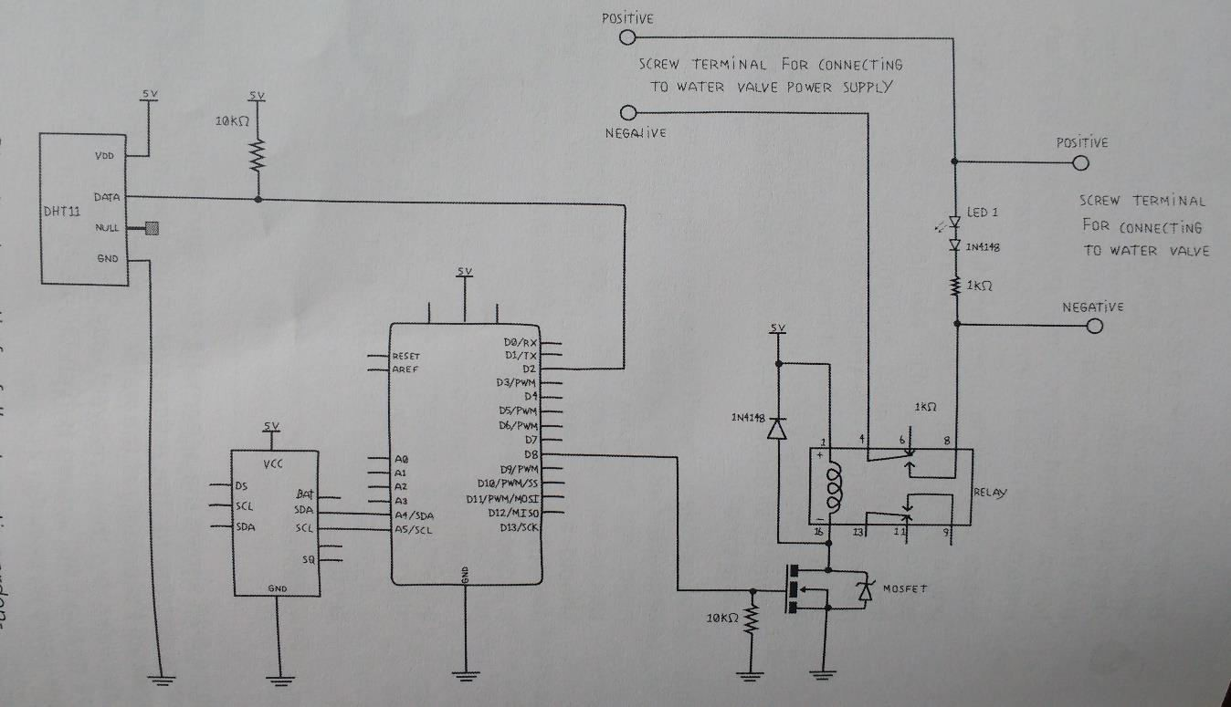

Fig 11: Circuit Schematic Diagram of the System

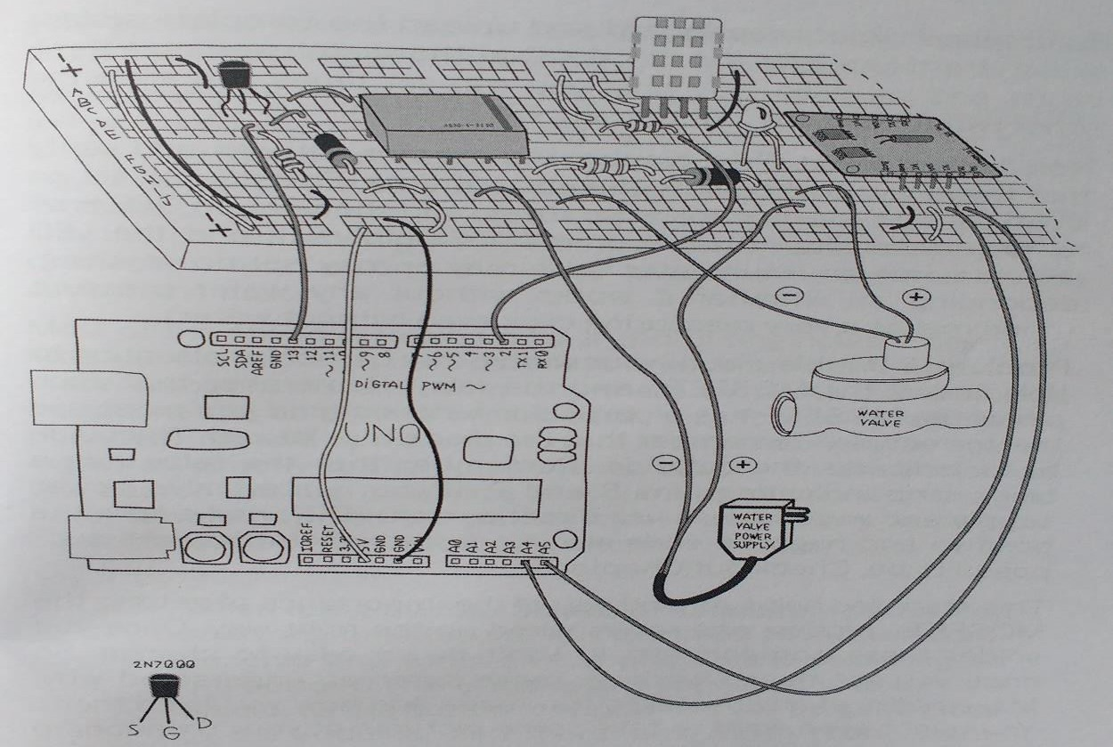

Fig 12: Pictorial Circuit Diagram of the System

# RESULT

## Print Settings of the Valve:

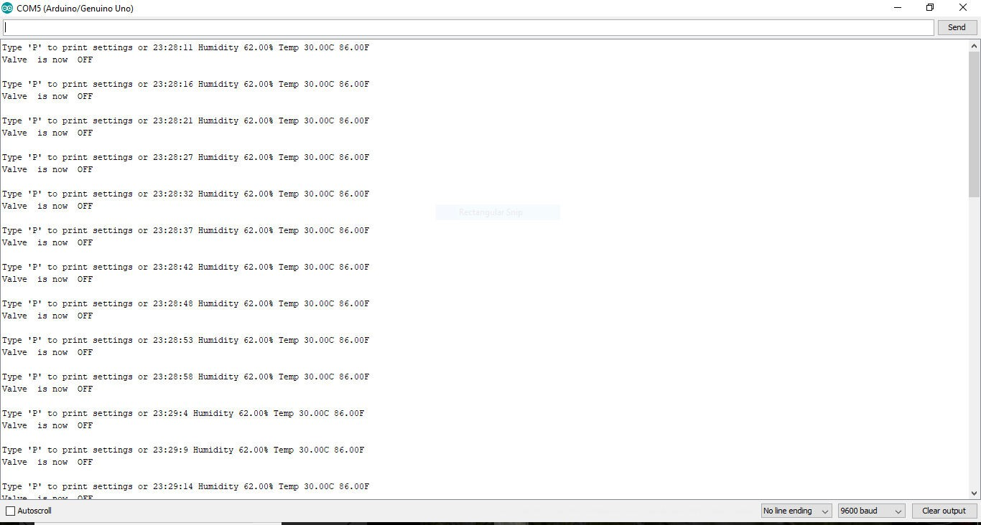

Fig 13: Print setting of Valve

## Valve is Open When Humidity is less than 80% and Timer is Set

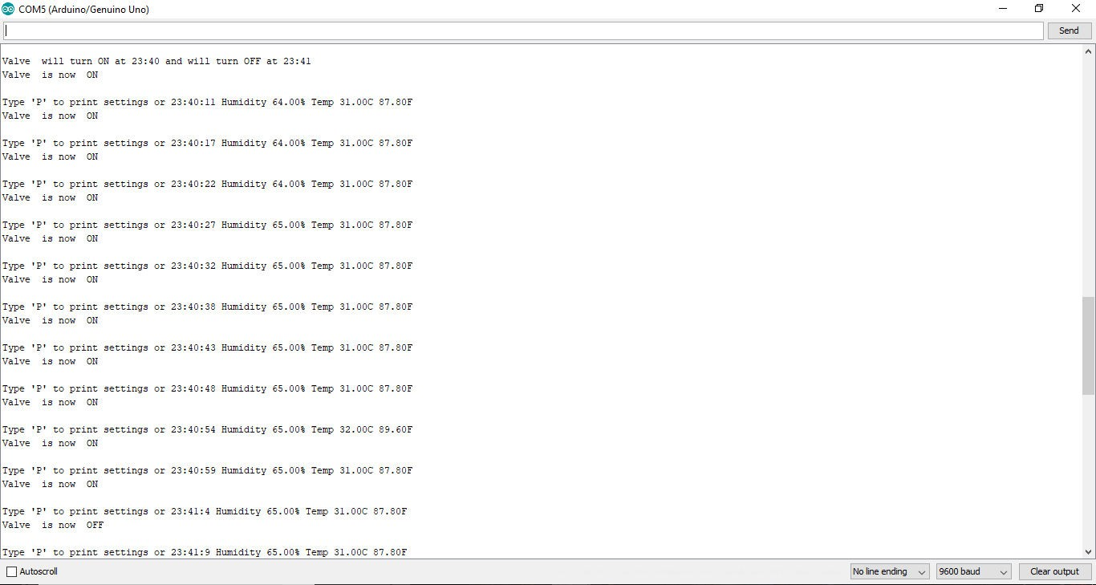

Fig 14: Output Result When Humidity less than 80%

## Valve is Closed When Humidity is More Than 80% Even When the Timer is On

Fig 15: Output When Humidity more than 80%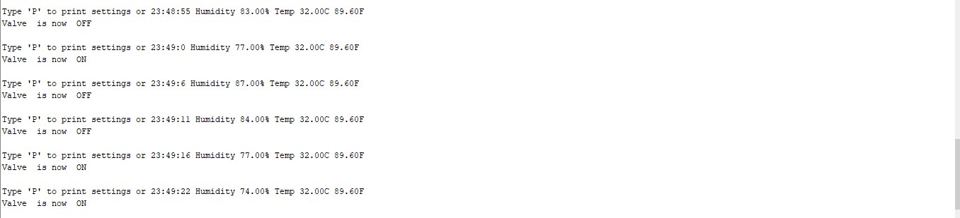

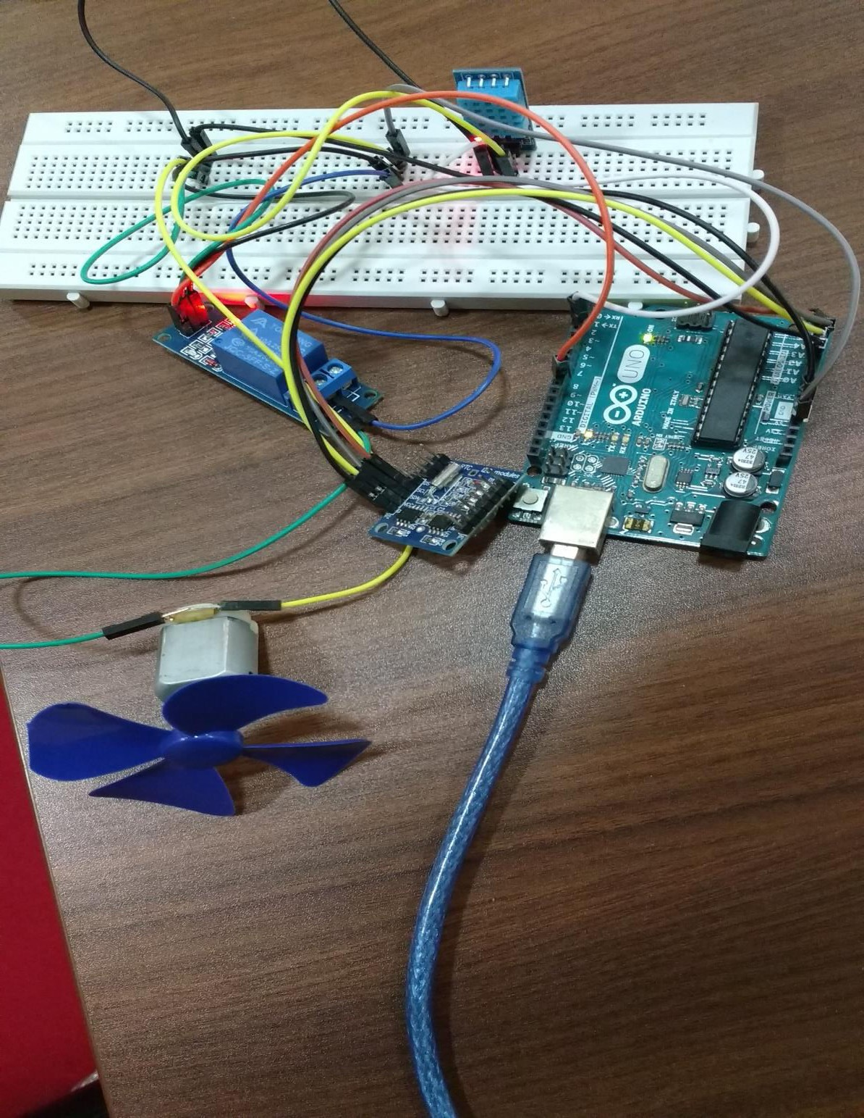

Fig 16: Hardware Model of the System

# CHAPTER 5: CONCLUSION AND FUTURE WORK

## CONCLUSION

The automatic irrigation control using arduino uno has been experimentally proven to work satisfactorily and we could successfully set the timer and managed to control the motor over time.This process not only records values of temperature and humidity it also controls the motor accordingly.Analyzing the weather condition motor will automatically maintain water supply making it possible to maintain greenery without human intervention.

## FUTURE WORK

Using this system as framework,the system can be expanded to include various other options which could include mobile application control of motor and wi fi controlled monitoring. These will expand the working capability and efficiency of this prototype.It can be implemented not in agriculture but in gardens in any places using the sprinkler concept.It has a vast scope when it is mixed with IOT .Automation will get a new dimension through this.

## REFERENCES

References / Bibliography 1. Attar, S., & Sudhakar, K. N. Real-Time Monitoring Of Agricultural Activities Using Wireless Sensor Network.

1..Awasthi, A., & Reddy, S. R. N. (2013). Monitoring for Precision Agriculture using Wireless Sensor Network-A review. GJCST-E: Network, Web & Security, 13(7)

2. Bhadane, G., Sharma, S., & Nerkar, V. B. (2013). Early Pest Identification in Agricultural Crops using Image Processing Techniques. International Journal of Electrical, Electronics and Computer Engineering, 2(2), 77-82.

1. 4. Bhasha, S. J., & Hussain, S. M. Agricultural field monitoring and automation using PIC16F877A microcontroller and GSM. nternational Journal of Advanced Research in Computer Engineering & Technology (IJARCET) Volume,
2. 5. Blackmore, S., Stout, B., Wang, M., & Runov, B. (2005, June). Robotic agriculture–the future of agricultural mechanisation. In Proceedings of the 5th European Conference on Precision Agriculture (pp. 621-628).
3. 6. Bulanon, D. M., Kataoka, T., Ota, Y., & Hiroma, T. (2002). AE—automation and emerging technologies: a segmentation algorithm for the automatic recognition of Fuji apples at harvest. Biosystems Engineering, 83(4), 405-412
4. . 7. Dahikar, M. S. S., & Rode, S. V. (2014). Agricultural crop yield prediction using artificial neural network approach. International Journal of Innovative Research in Electrical, Electronics, Instrumentation and Control Engineering,2, 683-686.
5. 8. Divya C. H., Ramakrishna, H. and Praveena Gowda, SEEDING AND FERTILIZATION USING AN AUTOMATED ROBOT, International Journal of Current Research Vol. 5, Issue, 03, pp.461-466, March, 2013, ISSN: 0975-833X

9. Edan, Y., Han, S., & Kondo, N. (2009).

1. Automation in agriculture. In Springer handbook of automation (pp. 1095-1128). Springer Berlin Heidelberg. 10. Fule, C. R., & Awachat, P. K. (2014). Design and Implementation of Real Time Irrigation System using a Wireless Sensor Network.
2. International Journal of Advance Research in Computer Science and Management Studies, 2(1).
3. 11. Galande, M. S., & Agrawal, D. G. (2013). Embedded Controlled Drip Irrigation System. International Journal of Emerging Trends & Technology in Computer